ultramirinc.champs_mood

Class BreakCreator

java.lang.Object

android.support.v4.app.Fragment

android.support.v4.app.DialogFragment ultramirinc.champs_mood.BreakCreator

All Implemented Interfaces:

android.content.ComponentCallbacks, android.content.DialogInterface.OnCancelListener, android.content.DialogInterface.OnDismissListener, android.view.View.OnCreateContextMenuListener, android.widget.AdapterView.OnItemSelectedListener



public class BreakCreator

extends android.support.v4.app.DialogFragment

implements android.widget.AdapterView.OnItemSelectedListener

Created by Etienne Berube on 2017­03­23. This class is a Pop­up that appears when the user wants to create a new Break Object for his schedule

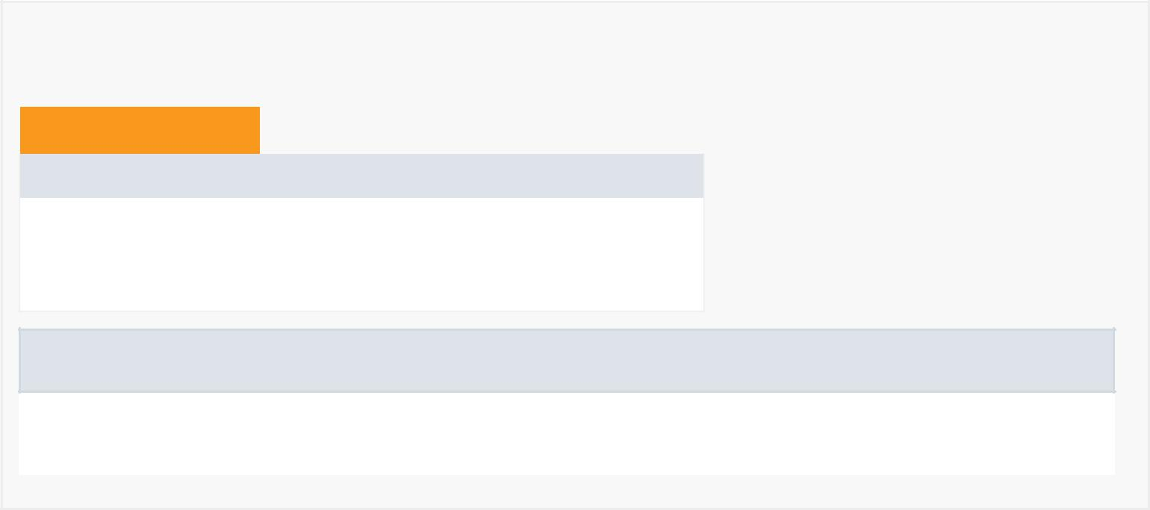

*Nested Class Summary*

Nested Classes

Modifier and Type Class and Description

static interface BreakCreator.OnBreakReadyListener

A Custom listener for when the break is ready.

Nested classes/interfaces inherited from class android.support.v4.app.Fragment

android.support.v4.app.Fragment.InstantiationException,

android.support.v4.app.Fragment.SavedState

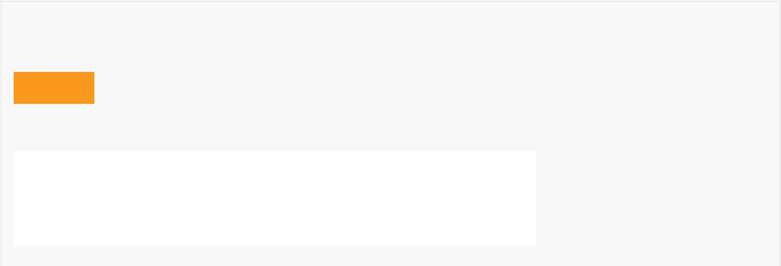

*Field Summary*

Fields

|  |  |
| --- | --- |
| Modifier and Type | Field and |
|  | Description |
| private android.content.Context | context |
|  | Contains the |
|  | context of the |
|  | attached activity |
|  |  |
|  |  |

|  |  |  |  |
| --- | --- | --- | --- |
|  | private java.lang.String | day |  |
|  |  | Day of the break |  |
|  | private android.app.TimePickerDialog | end |  |
|  |  | The |  |
|  |  | TimePickerDialog |  |
|  |  | for the ending |  |
|  |  | time |  |
|  | private int | endHour |  |
|  |  | The ending hour |  |
|  |  | of the break |  |
|  | private int | endMinute |  |
|  |  | The ending |  |
|  |  | minute of the |  |
|  |  | break |  |
|  | private android.widget.TextView | endTime |  |
|  |  | Contains the view |  |
|  |  | for the end time |  |
|  | private boolean | isCancelled |  |
|  |  | Is true if the user |  |
|  |  | cancelled the |  |
|  |  | break creation |  |
|  | private android.widget.Spinner | listDay |  |
|  |  | Contains the |  |
|  |  | drop­down menu |  |
|  |  | of the days of the |  |
|  |  | week |  |
|  | private BreakCreator.OnBreakReadyListener | mListener |  |
|  |  | Contains the |  |
|  |  | listener when the |  |
|  |  | break is ready |  |
|  | private android.app.TimePickerDialog | start |  |
|  |  | The |  |
|  |  | TimePickerDialog |  |
|  |  | for the starting |  |
|  |  | time |  |
|  | private int | startHour |  |
|  |  | The starting hour |  |
|  |  | of the break |  |
|  | private int | startMinute |  |
|  |  | The starting |  |
|  |  | minute of the |  |
|  |  | break |  |
|  | private android.widget.TextView | startTime |  |
|  |  | Contains the view |  |
|  |  | for the start time |  |
|  |  |  |  |



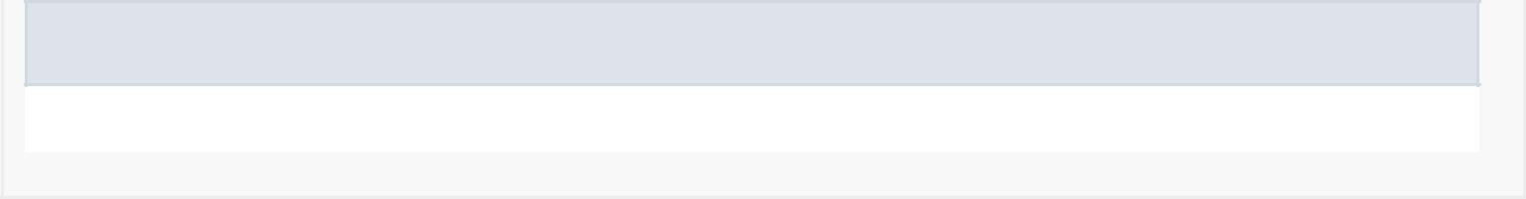Fields inherited from class android.support.v4.app.DialogFragment

STYLE_NO_FRAME, STYLE_NO_INPUT, STYLE_NO_TITLE, STYLE_NORMAL

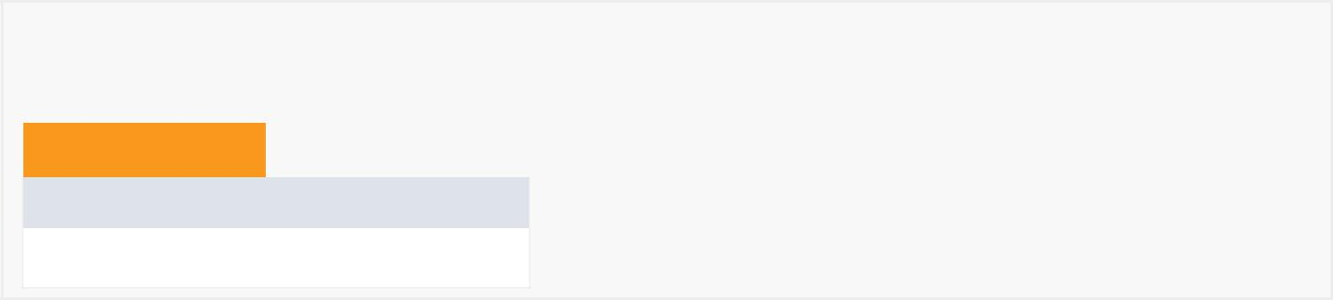

*Constructor Summary*

Constructors

Constructor and Description

BreakCreator()

|  |  |  |  |  |  |  |  |  |
| --- | --- | --- | --- | --- | --- | --- | --- | --- |
|  | *Method Summary* | | | |  |  |  |  |
|  |  |  |  |  |  |  |  |  |
|  | All Methods |  | [Static Methods](javascript:show(1);) |  | [Instance Methods](javascript:show(2);) | [Concrete Methods](javascript:show(8);) |  |  |
|  | Modifier and Type | |  |  | Method and Description |  |  |  |
|  | boolean | |  |  | checkIfComplete() |  |  |  |
|  |  |  |  |  | Check if the potential break is complete or if certain fields are | | |  |
|  |  |  |  |  | missing. |  |  |  |
|  | java.lang.String | | | | getDay() |  |  |  |
|  |  |  |  |  | Getter for day |  |  |  |
|  | int | |  |  | getEndHour() |  |  |  |
|  |  |  |  |  | Getter for endHour |  |  |  |
|  | int | |  |  | getEndMinute() |  |  |  |
|  |  |  |  |  | Getter for endMinute |  |  |  |
|  | BreakCreator.OnBreakReadyListener | | | | getListener() |  |  |  |
|  |  |  |  |  | Getter for mListener |  |  |  |
|  | int | |  |  | getStartHour() |  |  |  |
|  |  |  |  |  | Getter for startHour |  |  |  |
|  | int | |  |  | getStartMinute() |  |  |  |
|  |  |  |  |  | Getter for startMinute |  |  |  |
|  | boolean | |  |  | isCancelled() |  |  |  |
|  |  |  |  |  | Getter for isCancelled |  |  |  |
|  | static BreakCreator | | | | newInstance(int title) | | |  |
|  |  |  |  |  | Creates a new instance of this dialog. | | |  |
|  | void | |  |  | onAttach(android.content.Context context) | | |  |
|  |  |  |  |  | Gets context from attached activity. | | |  |
|  | android.view.View | | | | onCreateView(android.view.LayoutInflater inflater, | | |  |
|  |  |  |  |  | android.view.ViewGroup container, | | |  |
|  |  |  |  |  |  |  |  |  |



|  |  |
| --- | --- |
|  | android.os.Bundle savedInstanceState) |
|  | Inflates the visual layout of the dialog. |
|  |  |
| void | onItemSelected(android.widget.AdapterView<?> parent, |
|  | android.view.View view, int position, long id) |
|  | Selects a day from the dropdown menu when it is clicked on. |
| void | onNothingSelected(android.widget.AdapterView<?> parent) |
|  | Sets a default value when no day is selected in the dropdown menu |
|  |  |
| void | onResume() |
|  | Removes the keyboard from the screen when the dialog appears. |
| void | onViewCreated(android.view.View view, |
|  | android.os.Bundle savedInstanceState) |
|  | Sets listeners when the layout is inflated. |
|  |  |
| void | setEndTimeView() |
|  | Setter for endTimeView |
| void | setListener(BreakCreator.OnBreakReadyListener listener) |
|  | Setter for mListener |
|  |  |
| void | setStartTimeView() |
|  | Setter for startTimeView |
|  |  |

Methods inherited from class android.support.v4.app.DialogFragment

dismiss, dismissAllowingStateLoss, getDialog, getLayoutInflater, getShowsDialog, getTheme, isCancelable, onActivityCreated, onCancel, onCreate, onCreateDialog, onDestroyView, onDetach, onDismiss, onSaveInstanceState, onStart, onStop, setCancelable, setShowsDialog, setStyle, setupDialog, show, show

Methods inherited from class android.support.v4.app.Fragment

dump, equals, getActivity, getAllowEnterTransitionOverlap, getAllowReturnTransitionOverlap, getArguments, getChildFragmentManager, getContext, getEnterTransition, getExitTransition, getFragmentManager, getHost, getId, getLoaderManager, getParentFragment, getReenterTransition, getResources, getRetainInstance, getReturnTransition, getSharedElementEnterTransition, getSharedElementReturnTransition, getString, getString, getTag, getTargetFragment, getTargetRequestCode, getText, getUserVisibleHint, getView, hashCode, hasOptionsMenu, instantiate, instantiate, isAdded, isDetached, isHidden, isInLayout, isMenuVisible, isRemoving, isResumed, isVisible, onActivityResult, onAttach, onAttachFragment, onConfigurationChanged, onContextItemSelected, onCreateAnimation, onCreateContextMenu, onCreateOptionsMenu, onDestroy, onDestroyOptionsMenu, onHiddenChanged, onInflate, onInflate, onLowMemory, onMultiWindowModeChanged, onOptionsItemSelected, onOptionsMenuClosed, onPause, onPictureInPictureModeChanged, onPrepareOptionsMenu, onRequestPermissionsResult, onViewStateRestored, postponeEnterTransition, registerForContextMenu, requestPermissions, setAllowEnterTransitionOverlap, setAllowReturnTransitionOverlap, setArguments, setEnterSharedElementCallback, setEnterTransition, setExitSharedElementCallback, setExitTransition,

setHasOptionsMenu, setInitialSavedState, setMenuVisibility, setReenterTransition, setRetainInstance, setReturnTransition, setSharedElementEnterTransition, setSharedElementReturnTransition, setTargetFragment, setUserVisibleHint, shouldShowRequestPermissionRationale, startActivity, startActivity, startActivityForResult, startActivityForResult, startIntentSenderForResult, startPostponedEnterTransition, toString, unregisterForContextMenu

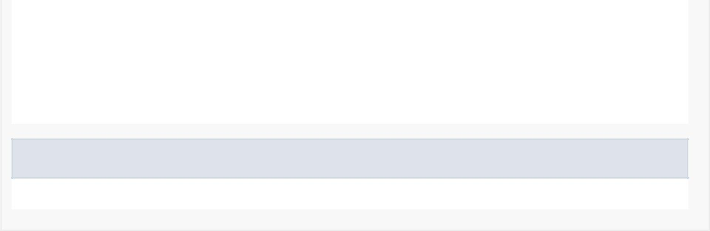

Methods inherited from class java.lang.Object

clone, finalize, getClass, notify, notifyAll, wait, wait, wait



*Field Detail*

isCancelled

private boolean isCancelled

Is true if the user cancelled the break creation

day

private java.lang.String day

Day of the break

startHour

private int startHour

The starting hour of the break

startMinute

private int startMinute

The starting minute of the break

endHour

private int endHour

The ending hour of the break

endMinute

private int endMinute

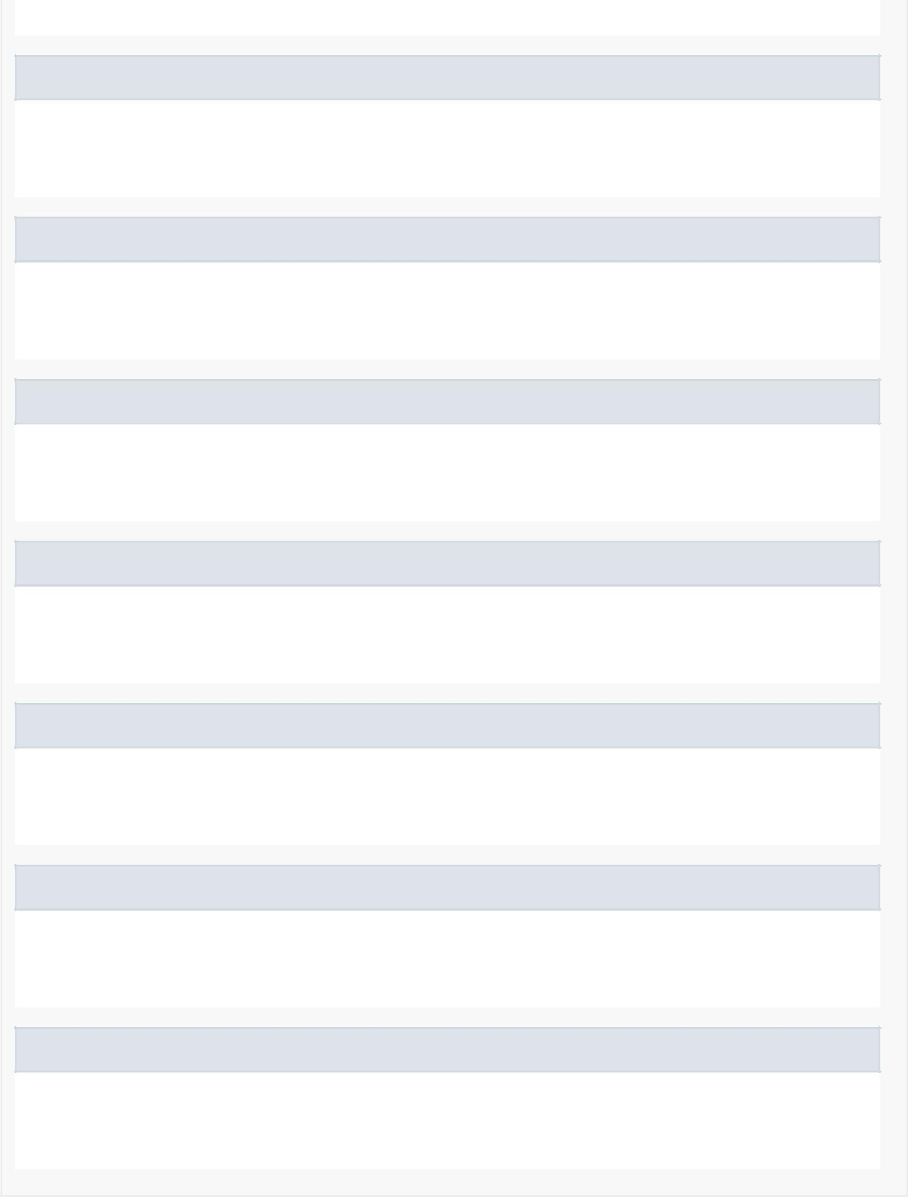The ending minute of the break

startTime

private android.widget.TextView startTime

Contains the view for the start time

endTime

private android.widget.TextView endTime

Contains the view for the end time

context

private android.content.Context context

Contains the context of the attached activity

listDay

private android.widget.Spinner listDay

Contains the drop­down menu of the days of the week

start

private android.app.TimePickerDialog start

The TimePickerDialog for the starting time

end

private android.app.TimePickerDialog end

The TimePickerDialog for the ending time

mListener

private BreakCreator.OnBreakReadyListener mListener

Contains the listener when the break is ready



*Constructor Detail*

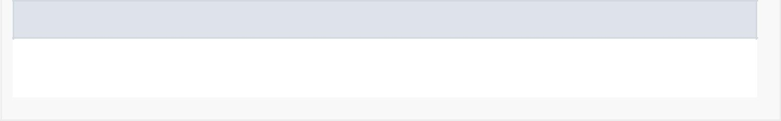BreakCreator

public BreakCreator()

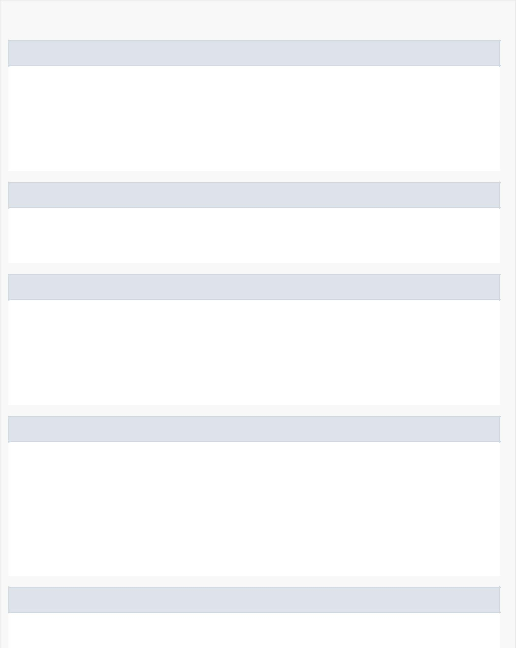

*Method Detail*

onResume

public void onResume()

Removes the keyboard from the screen when the dialog appears.

Overrides:

onResume in class android.support.v4.app.Fragment

newInstance

public static BreakCreator newInstance(int title)

Creates a new instance of this dialog.

onAttach

public void onAttach(android.content.Context context)

Gets context from attached activity.

Overrides:

onAttach in class android.support.v4.app.DialogFragment

onCreateView

public android.view.View onCreateView(android.view.LayoutInflater inflater, android.view.ViewGroup container, android.os.Bundle savedInstanceState)

Inflates the visual layout of the dialog.

Overrides:

onCreateView in class android.support.v4.app.Fragment

onViewCreated

public void onViewCreated(android.view.View view, @Nullable

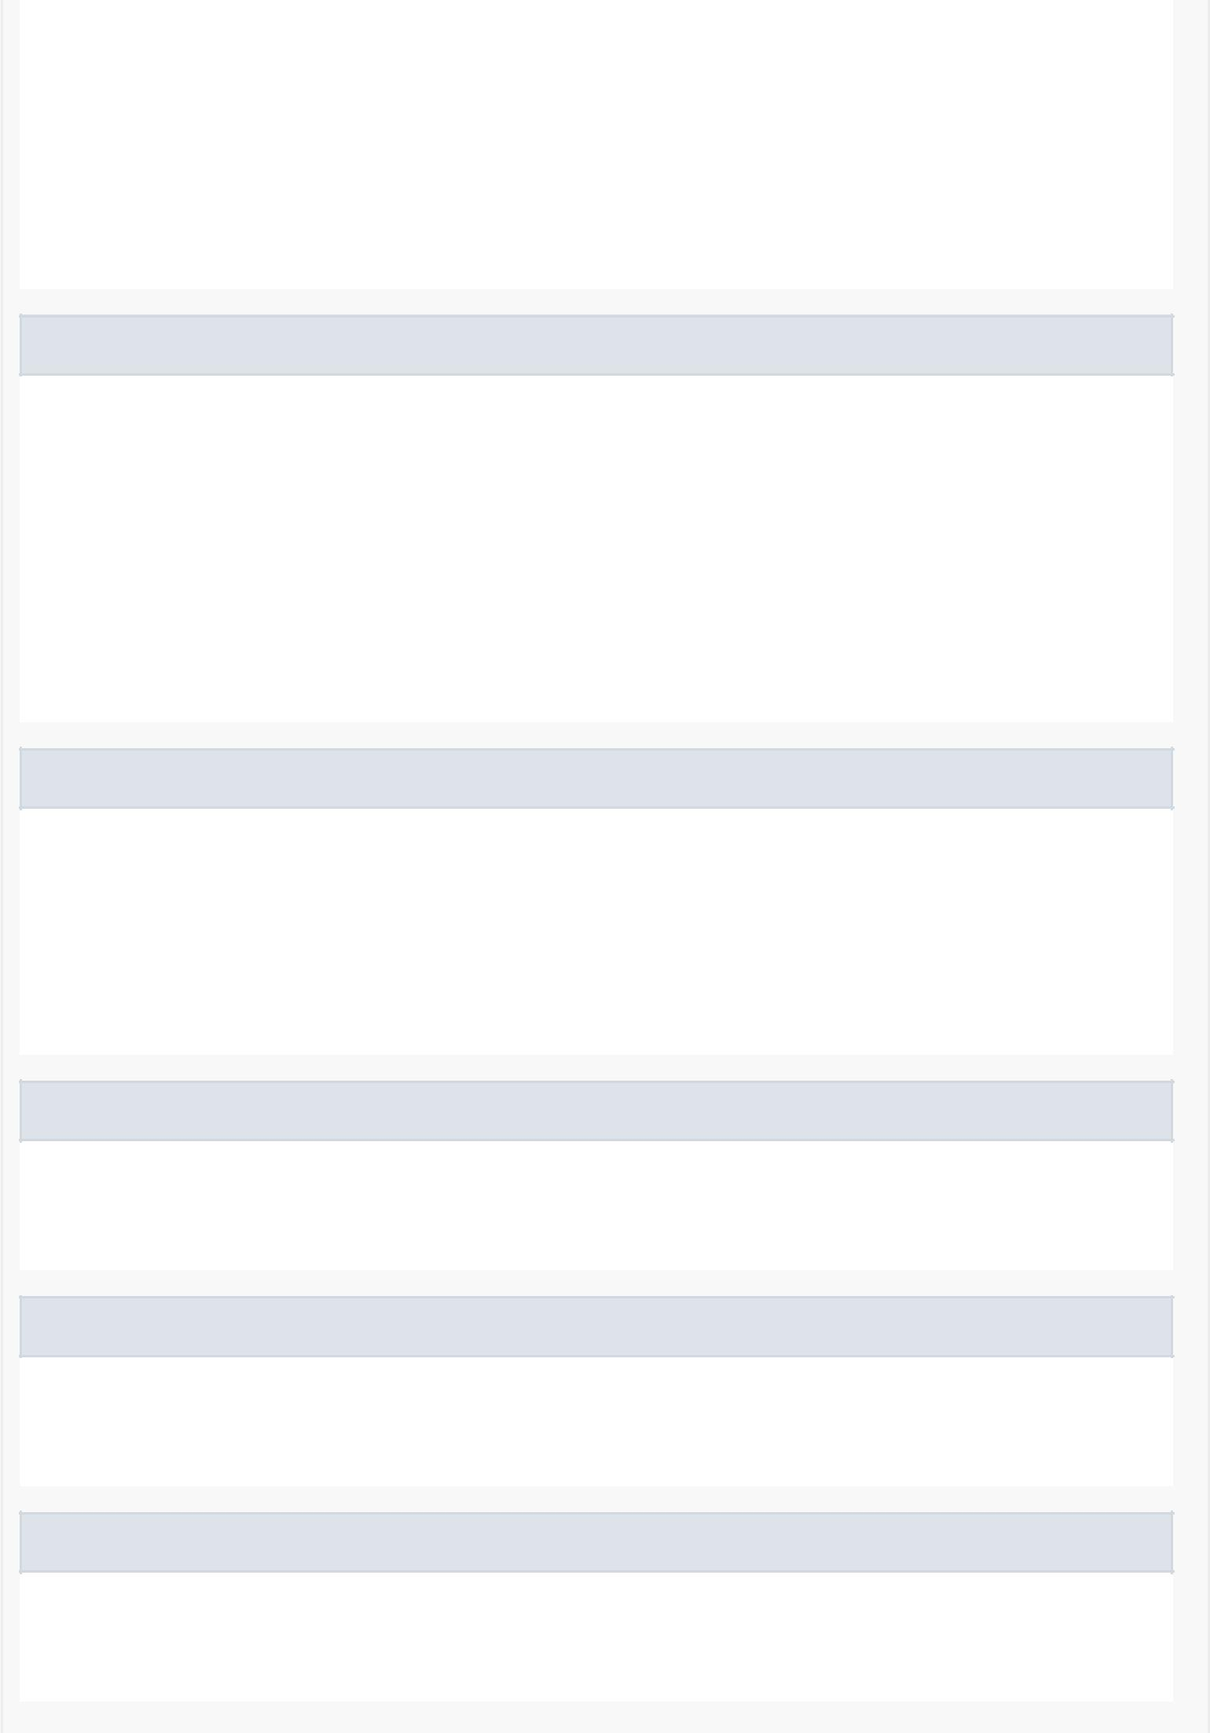android.os.Bundle savedInstanceState)

Sets listeners when the layout is inflated.

Overrides:

onViewCreated in class android.support.v4.app.Fragment

onItemSelected

public void onItemSelected(android.widget.AdapterView<?> parent, android.view.View view,

int position, long id)

Selects a day from the dropdown menu when it is clicked on.

Specified by:

onItemSelected in interface android.widget.AdapterView.OnItemSelectedListener

onNothingSelected

public void onNothingSelected(android.widget.AdapterView<?> parent)

Sets a default value when no day is selected in the dropdown menu

Specified by:

onNothingSelected in interface android.widget.AdapterView.OnItemSelectedListener

setStartTimeView

public void setStartTimeView()

Setter for startTimeView

setEndTimeView

public void setEndTimeView()

Setter for endTimeView

checkIfComplete

public boolean checkIfComplete()

Check if the potential break is complete or if certain fields are missing.

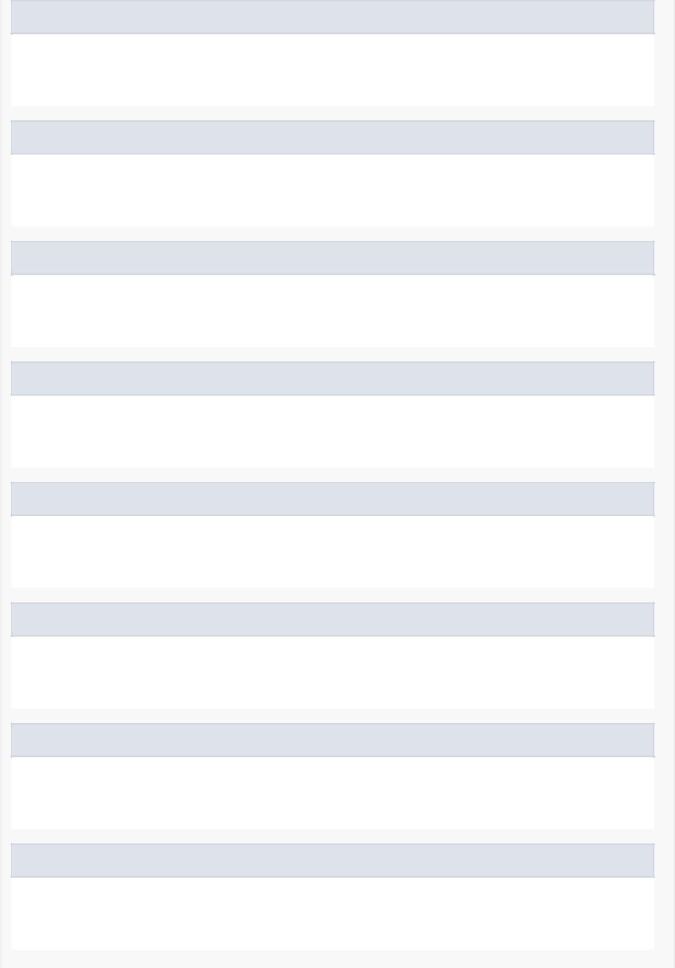isCancelled

public boolean isCancelled()

Getter for isCancelled

getDay

public java.lang.String getDay()

Getter for day

getStartHour

public int getStartHour()

Getter for startHour

getStartMinute

public int getStartMinute()

Getter for startMinute

getEndHour

public int getEndHour()

Getter for endHour

getEndMinute

public int getEndMinute()

Getter for endMinute

getListener

public BreakCreator.OnBreakReadyListener getListener()

Getter for mListener

setListener

public void setListener(BreakCreator.OnBreakReadyListener listener)

Setter for mListener

